PRACTICAL ASSESSMENT TASK 2: SUBTASK 1: WORKSHEET 1
Creating Github repo and research on Morse code
Student’s surname and First name/s | Mkhambi Lesego Elias
Student’s ID number | 0408066049086
Class group | IT & ROBOTICS L3
Assessment date
GitHub repo link.
https://github.com/settings/profile

GitHub README.md screenshot.
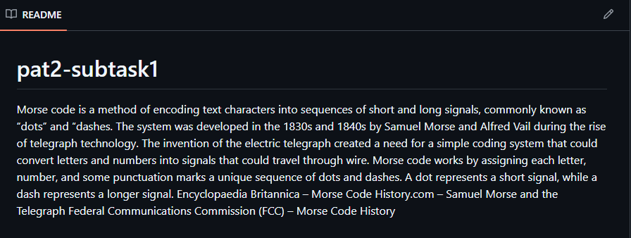

README.md copy
Morse code is a method of encoding text characters into sequences of short and long signals, commonly known as “dots” and “dashes. The system was developed in the 1830s and 1840s by Samuel Morse and Alfred Vail during the rise of telegraph technology. The invention of the electric telegraph created a need for a simple coding system that could convert letters and numbers into signals that could travel through wire. Morse code works by assigning each letter, number, and some punctuation marks a unique sequence of dots and dashes. A dot represents a short signal, while a dash represents a longer signal. Encyclopaedia Britannica – Morse Code History.com – Samuel Morse and the Telegraph Federal Communications Commission (FCC) – Morse Code History

PRACTICAL ASSESSMENT TASK 2: SUBTASK 2: WORKSHEET 2
C++ program for Morse code translation
Student’s surname and First name/s | Mkhambi Lesego Elias
Student’s ID number | 0408066049086
Class group | IT & ROBOTICS L3
Assessment date
GitHub repo link.
https://github.com/LOKHUNJA/pat2-subtask1.git

GitHub commit screenshot.
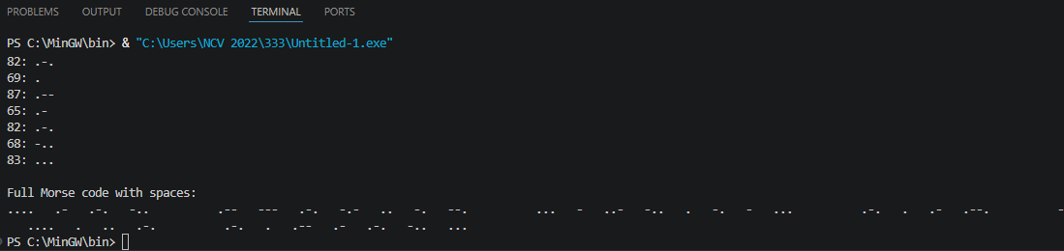

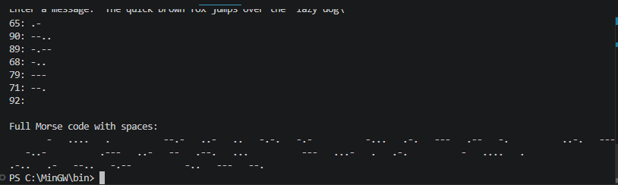
C++ Program source code
#0408066049086
#include <iostream>
#include <string>
#include <cctype>

using namespace std;

// Function to return Morse code for each letter
string getMorseCode(char letter)
{
switch (toupper(letter))
{
case 'A': return ".-";
case 'B': return "-...";
case 'C': return "-.-.";
case 'D': return "-..";
case 'E': return ".";
case 'F': return "..-.";
case 'G': return "--.";
case 'H': return "....";
case 'I': return "..";
case 'J': return ".---";
case 'K': return "-.-";
case 'L': return ".-..";
case 'M': return "--";
case 'N': return "-.";
case 'O': return "---";
case 'P': return ".--.";
case 'Q': return "--.-";
case 'R': return ".-.";
case 'S': return "...";
case 'T': return "-";
case 'U': return "..-";
case 'V': return "...-";
case 'W': return ".--";
case 'X': return "-..-";
case 'Y': return "-.--";
case 'Z': return "--..";
default: return "";
}
}

int main()
{
string message;
string fullMorse = "";

// Ask user for input
cout << "Enter a short message: ";
getline(cin, message);

cout << "\nMorse Code Translation:\n";

// Loop through each character
for (int i = 0; i < message.length(); i++)
{
char ch = message[i];

// Check for spaces between words
if (ch == ' ')
{
fullMorse += " "; // 7 spaces between words
}
else
{
string morse = getMorseCode(ch);

// Display letter and Morse code
cout << toupper(ch) << ": " << morse << endl;

// Add to full Morse message
fullMorse += morse + " "; // 3 spaces between letters
}
}

// Display full Morse code message
cout << "\nFull Morse code with spaces:\n";
cout << fullMorse << endl;

return 0;

PRACTICAL ASSESSMENT TASK 2: SUBTASK 3: WORKSHEET 3
C++ Error correction
Student’s surname and First name/s |  |  | Mkhambi Lesego Elias
Student’s ID number |  |  | 0408066049086
Class group |  |  | IT & ROBOTICS L3
Assessment date
Corrected C++ source code.
// FIXED: Added # before include statement
#include <iostream>

// FIXED: Added iomanip library for setprecision()
#include <iomanip>

using namespace std;

// Constants
const int NUM_EXPERIMENTS = 3;
const int NUM_READINGS = 3;

// FIXED: Changed float main() to int main()
int main()
{
// FIXED: Changed char variables to int variables
int i, j;

// Variables to store values
double readingValue;
double total;
double average;

// Loop through experiments
for (i = 1; i <= NUM_EXPERIMENTS; i++)
{
// FIXED: Added missing semicolon
total = 0;

cout << "\nEXPERIMENT " << i << endl;
cout << "====================\n";

// Loop through readings
for (j = 1; j <= NUM_READINGS; j++)
{
// FIXED: Added missing semicolon
cout << "Enter reading " << j << " value: ";

cin >> readingValue;

// FIXED: Changed subtraction to addition
total = total + readingValue;
}

// FIXED: Corrected average formula
average = total / NUM_READINGS;

// Determine range of average
// FIXED: Corrected logical condition
if (average < 100)
{
cout << "Experiment " << i << " average: "
<< fixed << setprecision(2)
<< average
<< " is Below acceptable range\n";
}

// FIXED: Replaced OR with &&
// FIXED: Corrected acceptable range logic
else if (average >= 100 && average <= 300)
{
cout << "Experiment " << i << " average: "
<< fixed << setprecision(2)
<< average
<< " is Within acceptable range\n";
}

// Above acceptable range
else
{
cout << "Experiment " << i << " average: "
<< fixed << setprecision(2)
<< average
<< " is Above acceptable range\n";
}
}

return 0;
}

Error correction list.
For each error you corrected, provide the following additional information:

Error Description Syntax or How was the error corrected
Logical

 | Include <iostream> missing # | Syntax Error |  | Changed to #include <iostream>
 | using namespace stt; | Syntax Error |  | Changed stt to std
 | float main() | Logic Error |  | Changed to int main()
 | char i, j; | Logic Error |  | Changed char to int
 | Missing semicolon after total = 0 | Syntax Error |  | Added ;
 | cout << "Enter reading..." missing semicolon | Syntax Error |  | Added ;
 | total = total - readingValue | Logic Error |  | Changed - to +
 | Missing semicolon after total calculation | Syntax Error |  | Added ;
 | average = total / NUM_READINGS + total; | Logic Error |  | Changed to average = total / NUM_READINGS;
 | if (average > 100) | Logic Error |  | Changed to average < 100
 | OR used in condition | Syntax Error |  | Changed to average >= 100 && average <= 300
 | average <= 100 OR average <= 300 | Logic Error |  | Added #include <iomanip>
 | fixed << setprecision(2) without <iomanip> | Syntax Error |  | C++ uses && and `
 | “Below acceptable range” message in wrong condition | Logic Error |  | Corrected condition structure
 | Within acceptable range” spelling | Syntax Error |  | Corrected spelling

Student’s Pledge
**Anti-Plagiarism Pledge for Introduction to Technical Programming**

I, ________________Lesego Mkhambi________, as a dedicated student of Introduction to Technical Programming, hereby solemnly pledge to uphold the principles of academic integrity, honesty, and originality throughout the duration of the conduct of the PAT and ISAT. I understand the importance of maintaining the highest ethical standards in my academic work, and I commit to the following:

- **Original Work:** I pledge that all work I submit for this course, including assignments, reports, and projects, will be entirely my own original work, created specifically for this class.

- **No Plagiarism:** I will not engage in any form of plagiarism, including but not limited to copying content from the internet, fellow students, or any other external sources without proper citation. I understand that plagiarism is a serious academic offense and will not be tolerated.

- **Proper Citation:** If I use external sources or reference materials in my work, I will cite them appropriately using the citation style specified by the instructor. I will give credit to the original authors and sources to acknowledge their contributions to my work.

- **Respect for Intellectual Property:** I will respect the intellectual property rights of others and adhere to all copyright laws when using external sources in my assignments or projects.

- **No Unauthorized Sharing:** I will not share my work with other students who might use it inappropriately, nor will I seek or accept work from others to submit as my own.

- **Academic Honesty:** I will report any suspected instances of academic dishonesty to the instructor or appropriate authority and support the maintenance of academic integrity within the class.

By taking this pledge, I am committed to maintaining the highest standards of academic integrity, and I understand that any violation of this pledge may result in academic consequences, including but not limited to failing grades or disciplinary action. I pledge to do my best to uphold these principles and promote a culture of academic honesty and excellence within our community.

Student details: _LE Mkhambi_______________
Date: ___________________27/05/2026_______________

Student’s Declaration of Authenticity
Student surname and  initials | Mkhambi L.E | ID  Number | 0408066049086
Subject | Introduction to Technical Programming
Select 1  - Practical Assessment Task One (PAT 1)  - Practical Assessment Task Two (PAT 2)  - Integrated Summative Assessment Task (ISAT) |  | Lecturer
I hereby declare that the contents of this assessment task are my own original work (except where there is clear acknowledgement and appropriate reference to the work of others) and have not been plagiarised, copied from someone else or previously submitted for assessment by anyone.

L.E Mkhambi
_________________________ _27__ / __05_ / 2026
SIGNATURE OF STUDENT DATE

